INTERVIEW QUESTIONS
C#:

OOPS PRINCIPLES

A programming language which will support following principles
1. Encapsulation
2. Abstraction
3. Inheritance
4. Polymorphism

Encapsulation: -
* Encapsulation means adding/binding of variables and methods with in a class.
*Through class we can achieve the encapsulation.
* Class is a container.it adds variables and methods as one unit.

Data abstraction: -
* Data Abstraction is a used to show only required data to the user and hides unwanted data to the user.
* By using access modifier concept we can achieve the Data abstraction.

POLYMORPHISM:
Implementing multiple methods with the same name with different
functionalities is called as polymorphism

Polymorphisms are classified into 2 types
===================================
1) Static polymorphism or Compile time polymorphism or method overloading or early binding.
2) Dynamic polymorphism or Run Time polymorphism or method overriding or late binding.

==========Method overloading important points=============
*overloading always depends on method name is same and parameters combination should be different.
*same parameters combination should not repreat.it does not depend on return type always check method name and parameters.
parameters always fallow 3 rules
1.Type of parameter
2.ordee of parameter
3.no.of parameter
should be different in overloading.

===========Method overriding Important points For interview=============

*if you want to implement overriding 2 classes required(1 parent class and 1 child class)
*parent class method having virtual keyword before return type.
*child class method having override keyword before return type.
*Same method name and same parameters we will use in parent and child class.
*then only we can implement the overriding concept.
*without inheritance we can't implement method overriding.
*when you run the program, Compiler always checks for override keyword method first in runtime. If it is available it will call override method.
*if there is no override keyword in child class it will call the parent class virtual method.
*override method always in child class
*To override the method is optional.(not a mandatory)
*If there is no override method compiler will give next preference to virtual method.
*without virtual method in the parent class. you can't override the method.(THIS IS THE RULE).
*WITHOUT INHERITENCE YOU CAN'T IMPLEMENT OVERIDING CONCEPT.

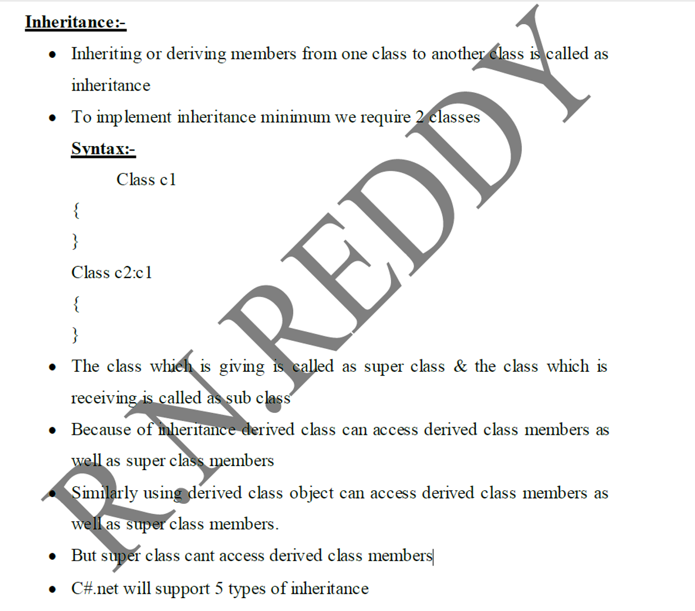
=============================================================================

Method definition:
================
*Method is a subprogram and it is used to perform operations on variable and return the data. method inside we can write logic also as per requirement.
Note: -
* If we write Void as return type then no need to return value
*If we write Data type as return type we should return that particular data type value.

Method Syntax: -
accessmodifier Return type Methodname ( parameters or arguments)
{
return data;
}
================
For accessing the method we should give
Objectname.method name ( );
==================================================================================
Interface:

=>It is an agreement between itself and its implemented classes.

An interface is a completely "abstract class", which can only contain abstract methods
and properties but not variables.

* Class does not support multiple inheritance to overcome this problem we are
going for interface concept.

=> We can achieve multiple inheritance in C# by using interface.

=>We can implement abstract methods using interface concept.

* Interface members are by default abstract and public.
 An interface cannot contain a constructor (as it cannot be used to create objects)

*What type of methods supports interface?
Only abstract methods

*Why we are going for interface?
Class does not support multiple inheritance to overcome this problem we are going
for interface.

We can perform multiple inheritance using interface
We can implement abstract methods using interface concept

Can we Create object to interface?
1. No, Interface is not a class
2. Interface consists of only abstract methods, in order to provide body to abstract methods
some other class needs to inherit interface and that needs to implement abstract methods.

Can we declare static methods inside interface?
No, Static methods should be implemented at the time of declaration due to that we can't
have static methods inside interface.

Note: while implementing multiple inheritance by using interface we need to keep class name first and then we need to keep interface name

Abstract Class:
*If you want to create any class as abstract class, class before use abstract keyword.
*In normal class whatever you are perform all the things you can do in abstract class also.
*here abstract class we just add abstract methods, abstract properties....create for future
implementation

* A class which contains one or more abstract function or non-abstract functions is known as abstract class.
* To make any class as abstract use abstract keyword
* It is compulsory to create new derived class from abstract class.
* Abstract METHODS contains only method heading but not method body
* Abstract METHOD Tells “what to do” In Future, if you want you can implement in child class.
* It contain both abstract and non-abstract function/Method
* We can’t declare static methods as abstract method but inside a abstract class we can declare static method (non abstract method)
* Abstract class always acts like a base class.
*In one abstract class writing at least one abstract method is optional.
*if you are not writing any one abstract method abstract class will not throw any error.

public abstract void DisplayManagerData();//this is abstract method, it contains only method heading(or)method declaration.it doesn't contain method body

*abstract method doesn't contain method body, if you create method body, it will throw compile time error.

Abstract function/Method:

A function/method which contains only method Heading but not method body is known as abstract function/method.
To make any function/method as abstract we use keyword "abstract” keyword.

If you inherit abstract class to derived class ,Overriding is compulsory for abstract function in child class.

sealed class:

A class which cannot allow a new class to derive is called as sealed class

• To make a class as sealed we must use key word Sealed
• Sealed class is completely opposite to abstract class
• Sealed class must write bottom class within the inheritance process
• Sealed class cannot contains abstract function
• Sealed class never used as base class
• It is mainly used to avoid inheritance

Sealed method:
The sealed method in C# cannot be overridden further. It must be used with override keyword in method.

Partial Class:

* Partial class is used to divide huge amount of logic into simple parts
* It must be declared with keyword “partial”
  By using partial class, application development is made faster.

*If any big task we can divide to multiple persons .they can write the same logic by using partial class.

ACCESS MODIFIERS

Public:

If we declare a variable or method or class as public, then we can use those variables in same project and also in new project also.

Private: you can't apply private to the class before.it will throw error.

If we declare a variable or method or class as private , then we can use those variables only in same class.

Internal: internal is used within the project only. outside project you can't access internal class/variables and methods
If we declare a variable or method or class as internal, then we can use those variables in same assembly(or project) only

Protected:-

If we declare a variable as protected, then we can use those variables in same class and derived class .

property will have two accessories

1) Set accessor
2) Get accessor

syntax for property:

Set Accessor: It will assign the value to variable.

Syntax:

<Access modifier><data type><property name>
{
Set
{
<data member or variable name>=value;
}
}
Get Accessor: This accessor will be reading the value or retrieving the value from variable.

Syntax:

<access modifier><data type><property name>
{
Get
{
Return <data member or variable name>;
}
}

Note: inside class variable we can also called data member.
By using this property .we can get the data from variable name and we can set or assign the data to variable name.

properties are classified into two types.

1) Non static property or instance property.
2) Static property.

Instance property: - while defining a property if we Didn't use static keyword
which can be called as instance property.

Using instance property we can assign value to an instance variable as well as
we can retrieve value from instance variable.

Static property: - while defining a property if we use static keyword then that
property is called as static property.

Using this property we can assign a value to static variable as well as we can retrieve value from static variable.

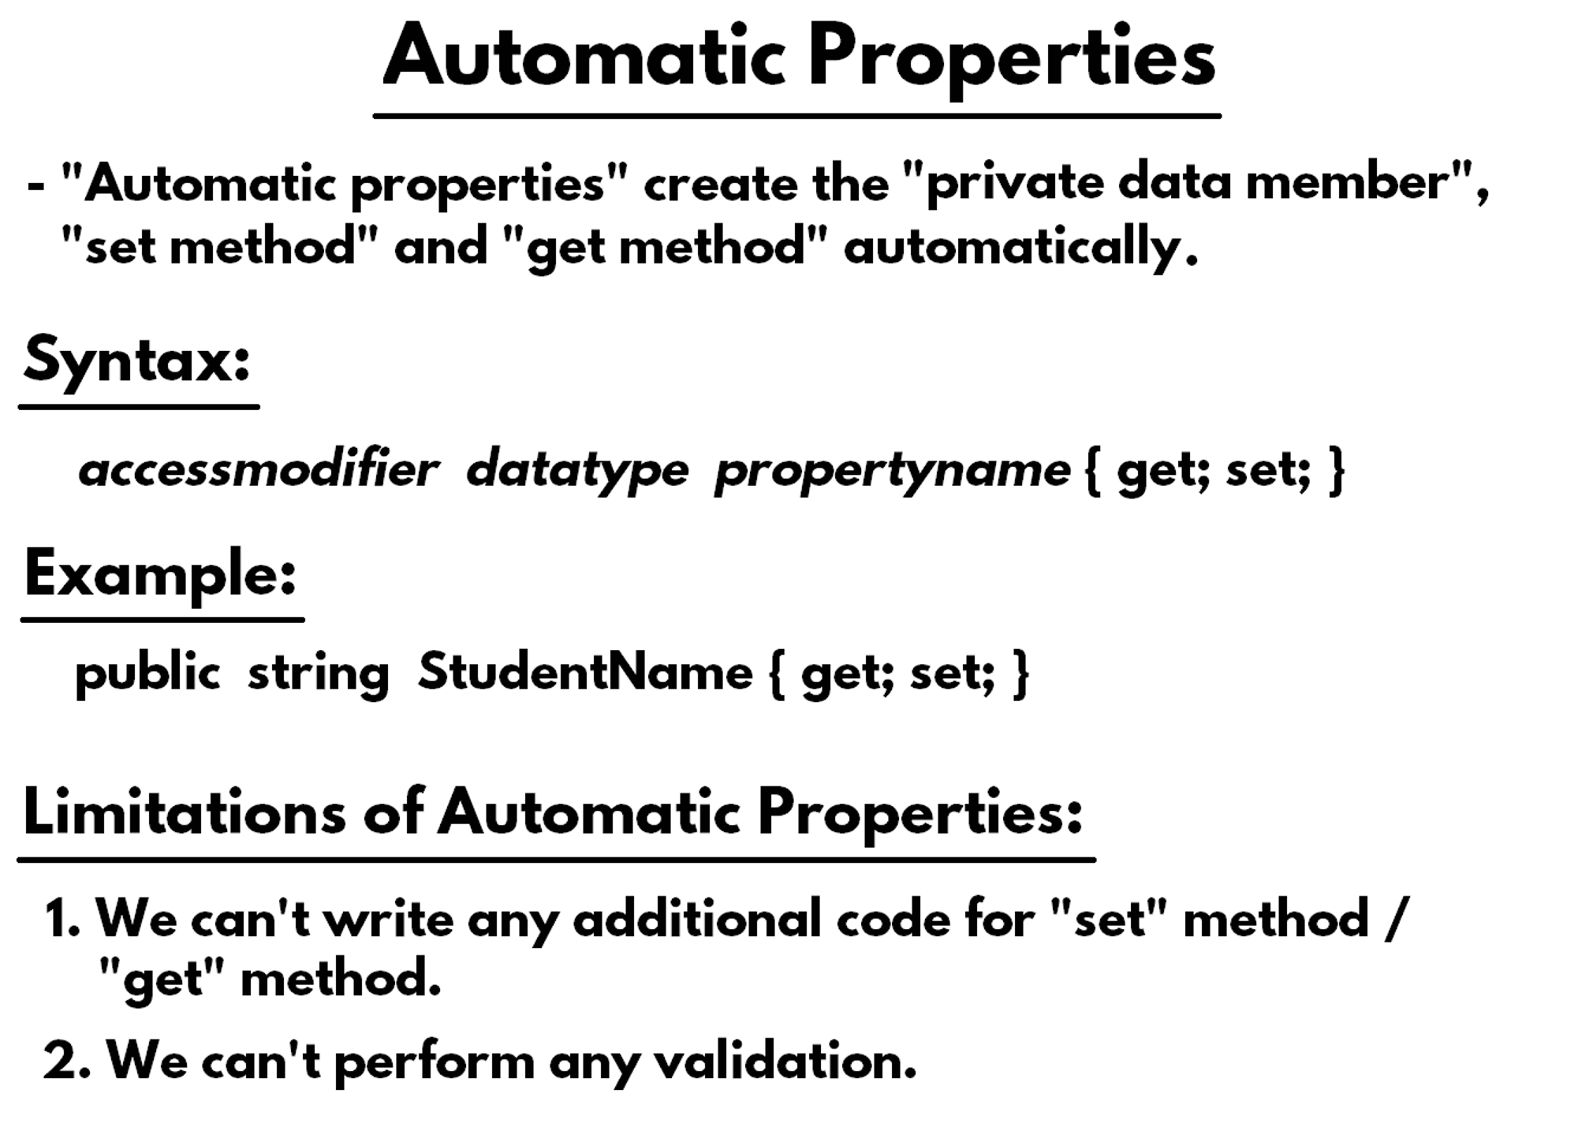
Passing a value to a function is called as passing parameter mechanism.

Q) Why we have to pass a value to the function?
A) According to the requirement if that function is required some values for
functionality, to invoke that function we have to pass some value.

Q) How to pass a value to the function?

A) To pass a value to the function we are taking the help of parameters.

Q) What is parameter?
A) A variable which is declared within the method signature can be called as
Parameter.

Parameters are classified into two types

1) Actual parameters
2) Formal parameters

Actual parameters: Calling function parameters are actual parameters

Formal parameters:
public static void Add(int a, int b)//here int a, int b we called as parameters. we called this is also " formal parameter"

C#.net will support passing parameter mechanism in three ways

1) Call by value or pass by value
2) Call by reference or pass by reference
3) Call by out or pass by out

1) Call by value:(by default mechanism of method passing is call by value)

=> In call by value when formal parameters are modified, the modifications will
not be reflected back to actual parameter.

=> In call by value while passing the parameter we will pass actual value

2) Call by reference:(modified values will reflect back here from the method)

=>In call by reference when formal parameters are modified the modifications
will be reflecting back to actual parameters.
=> In call by reference while passing the parameters and while catching the
parameters we should use “Ref” keyword
=> Ref parameter should be initialized with some value otherwise compiler will
generate an error.

3)Call by out:(modified values will reflect back here from the method)

=>In call by out when formal parameters are modified those modifications will be
reflected back to actual parameters it is almost all same as call by reference.
=>In call by out while passing the parameters and while catching the parameters we
have to use out keyword.
=>Out parameter is not required to initialize with any value if we initialize also CLR
will ignores that value.
=>In call by out also while passing the parameters we are passing the address of the
parameter.

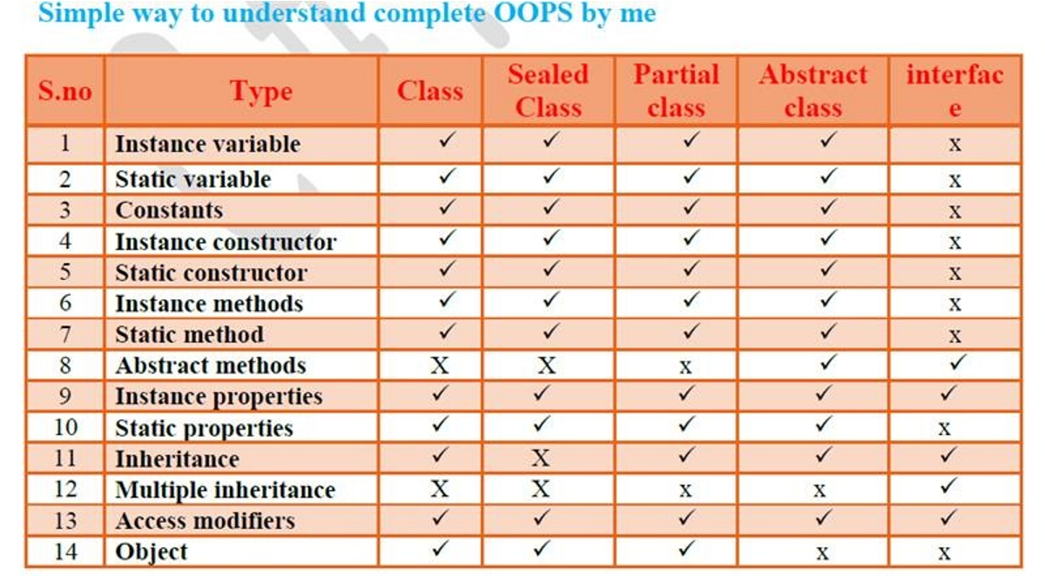
=========================================
COLLECTIONS

* Collection is used to implement data structures in.net.
* It is used to store heterogeneous (dis-similar) data
Collections are collection of same variable multiple values of different data types.
* In.net to work with collection we have to use the name space “Using system.collections” and
System.Collections.Generic classes

Types of Sytem.Collection:-Basically we have below types of collection.
1. Array List
2. Stack
3. Queue
4. Hash table
5. Sorted List

1) ArrayList:-
* It is used to store heterogeneous values. Here the size is not fixed we can declare dynamically
It is predefined class under “using system. Collections” namespace

Some predefined methods that are available in array list
1. Add ();
This method is used to add items to arraylist
2. Remove ();
This method is used to remove particular item in array list it removes item by default
either start or last values
3. Insert ();
This method is used to insert the item in arraylist at particular index insert (index, value)
4. Remove at ();
This method is used to remove the particular item in arraylist at particular index.
5. Clear ();
This method is used to clear all the values.
6. Reverse();
This method is used to reverse the items in reverse order
7. Sort ();
This method is used to sort the items in arrays

Count property:-
This is used to count the number of items in arraylist

For each syntax:-
The foreach statement repeats a group of embedded statements for each element in an
array or an object collection. You do not need to specify the loop bounds minimum or maximum.

Syntax: For each (datatype variable-name in collections)
The following code loops through all items of an array.
foreach syntax: //by using loops we can print the data of collections and arrays
foreach(datatype variableName in collection/array)
{
Console.WriteLine(variableName); //by using you can print the data or do something
}

Difference between For and foreach loop
==================================
1. The for loop executes a statement or a block of statements repeatedly until a
specified expression or condition becomes to false.
2. There is no need to specify the loop bounds (minimum or maximum).

2) Stack:
==============
Stack will arrange the data in LIFO (last in first out) format
It has two methods
1. push( ) : - this is used to add items in the stack
2.pop( ) :- this is used to remove items from the stack

3) Queue:
================
Queue will arrange the data in FIFO (first in first out)
It has two methods
1. Enqueue:-it is used to add items to the queue
2. Dequeue: - it is used to remove items from the queue

4) Hash table:
===================
1) It will arrange data in the form of key and value format
2) It will maintain the data in DictionaryEntry interface
3) It will arrange data based on key and value format.
4) It will arrange data in descending order

5) Sortedlist:-
=======================
1) It will arrange data in key and value pair format.
2) It will maintain data in dictionary-entry interface
3) It will arrange data based on key
4) It will arrange data in ascending order

=========================================================

Basically collections two types. They are
1.Normal Collections
2.Generic Collections

1.Normal Collections:

=> It is used to store heterogeneous (dis-similar) data.
=> Collections are collection of same variable multiple values of different data types.
=> In.net to work with collection we have to use the name space “Using system.collections”

Types of Sytem.Collection:-Basically we have below types of collection and below are them.

1. Array List
2. Stack
3. Queue
4. Hash table
5. Sorted List

2.Generic collections:
In.net to work with collection we have to use the name space ''System.Collections.Generic" classes

System.Collections.Generic classes are
1. LinkedList
2. Dictionary
3. SortedDictionary
4. SortedList
5.Lists

Syntax:
Collectionname<datatype> objectname = new Collectionname < datatype >();

2. Dictionary
C# Dictionary<TKey, TValue> class uses the concept of hashtable.
C# Dictionary stores values on the basis of key.
C#Dictionary stores key ,value format of data.
It contains unique keys only.(don't add duplicate key here. if you add duplicate key it will throw error.
By the help of key, we can easily search or remove elements
Syntax of Dictionary class:
===========================
Dictionary<TKey, TValue> obj=new Dictionary<TKey, TValue>();
===============================================================
Note:TKey you can give any datatype,TValue you can give any datatype value
Key must be unique. same key can't repeat multiple times. if you repeat it will throw error.

Errors are 2 types
1.compiletime error: if you write the code, in that time if you face any error ,we called that error is compile time error.

2.Runtime error: if you execute the program if you face error at running the program that error we called runtime error.

Exception Handling Syntax:
========================
To handle the Exceptions we have 3 blocks.
1.Try block,
2.Catch block,
3.Finally block

Try ===>(Try Block)
{
//code expected to generate a runtime ever
}
Catch (Exceptionclassname refrencevariable) ====>(Catch Block)
{
// what to do in exception case
}
Finally ====>(Finally Block)==>(it is optional not a mandatory block)
{
//Finally block always write the code for object removing/clean up code we will write it's optional(not a mandatory)
//code to close the object (or) clearing/Removing the object data code written in finally block.
}

Class Library Project:
we can't execute the classlibrary project. If you try to execute the class library project it will throw the error.
always claslibrary project we can add rfrence to any consoleapplications or webapplications or any other projects .
class library project does not conatin main method.
===========================================
ClassLibrary:(Generates .dll file)
====================
1.when you build the class libraray project it will generate the .dll file.(dll fullform is dynamic link libraray)
2.class library project doesnot contain main method.
3.in class library project we can write all types(like--All type of classes,enums,interfaces,abstarct classes,delegrtes...and all we can write)
4.but this types we can not exceute in class library project.because class library project does not having a main method.
5.This class library project generted dll file.this dll file we can add refrence to some other projects and we can reuse it .
6.you can add this dll file to console application and webapplications...wherever you need you can add refrence to these dll file to that project
==========================================
how to see the dll (or) exe file file.
========================================
Rightclick on project =>openinFileExplorer=>bin=>Debug=>here you can see the dll or exe file.

Note:
=======
1.if you are taking console application,when you build the application "projectname.exe" file generated.
2.if you are taking class library project, when you build the application "projectname.dll" file generted.

ConsoleApplication:(Genertes .exe file)
=========================
1.when you build the ConsoleApplication project it will generate the .exe file.(exe fullform is excutable)
2.ConsoleApplication project contain main method.in this main method we can call the methods of another class.beacuse program excution starts from main method.
3.in ConsoleApplication project we can write all types(like--All type of classes,enums,interfaces,abstarct classes,delegrtes...and all we can write)
4.but these types we can exceute in ConsoleApplication project.
5.This ConsoleApplication project generted .exe file.this exe file we can not add refrence to some other projects,beacuse exe file is executable .
6.This exe file we can't add refrence to some other projects.like (class libraries....web applications..)

STRING METHODS IN C#

Common String Predefined Methods in C#
Method | Purpose
Length | Gets the number of characters in a string
ToUpper() | Converts string to uppercase
ToLower() | Converts string to lowercase
Trim() | Removes extra spaces from start and end
Substring() | Extracts part of a string
Contains() | Checks if a string contains specific text
Replace() | Replaces characters or words
Split() | Splits a string into parts
StartsWith() | Checks starting text
EndsWith() | Checks ending text

Example: ToUpper() Method
Program:
using System;
class Program{
static void Main()
{
string name = "hello world";
string result = name.ToUpper();

Console.WriteLine(result);
}
}
Explanation:
- name stores the string "hello world"
- ToUpper() converts all characters to uppercase
- Output will be:
HELLO WORLD

CODING STANDARDS:

Naming Conventions Followed In RealTime Projects:
1.Pascal Casing rule:
====================
First character of all words are Upper Case and other characters are lower case.
Example:EmployeeName
2.Camel Casing rule:
==============
•First character of all words, except the first word are Upper Case and other characters are lower case.
Example :employeeName

Ternary Operator

Ternary operator: Condition ? True value: Falsevalue
===============
syntax: condition ? first expression : second expression;
(or)
syntax: condition ? True expression: False expression;
Operators:
BOOL IS A DATATYPE .IT WILL STORE ONLY TRUE OR FALSE ONLY.
*CASES:
--------------
AND Operator:

TRUE && TRUE=>TRUE
TRUE && FALSE=>FALSE
FALSE && FALSE=>FALSE
OR Operator:

TRUE || TRUE=> TRUE
TRUE || FALSE=> TRUE
FALSE || FALSE=> FALSE
NOT Operator

!TRUE=> FALSE
!FALSE=> TRUE
Simple IF:

Syntax for simple if:

If (condition)
{ //open curly bracket
Statements;(here we can write c# code)
}//close curly bracket
*here condition is True it will go to inside if condition.
*here condition is False it will not go inside of if condition.

if else

syntax for if else

if (condition)
{
Statement
}
else
{
Statement
}

Note: - If condition is true it executes the If block. Otherwise it goes to else block.

Nested if

In c#.Net nested if or if else or else if works one inside another if or else if statement(s).
Syntax:

if (condition) {

if (condition)
{
Statements;
}
}

- in one if condition inside if you write another if condition we called this as nested if .

SWITCH CASE

Syntax:

Switch (condition)
{
Case 1:
Statements;
Break;
Case 2:
Statements;
Break;
Default:
Statements;
Break;
}

- break is used to for exist purpose used
- note: continue is used to skip the current iteration and jump to the next iteration.

- in switch case only one condition is executed among multiple condition.

While loop

Syntax: -
Initialization;
While (condition)
{
Statements;
Increment /decrement;
}

Example:

long i = 1; //Initialization;
while (i <= 10)//here it will check the condition.if it true it will go inside while loop
{
Console.WriteLine("hai");
//Console.WriteLine(i);// Statements;
i++;//Increment the i value;//it means i=i+1
//here ++ is increment the value
//here -- is decrement the value
}

do while loop

Syntax:-
===========
initialization
do
{
Increment /decrement;
}
While (condition);

Note: do while loop will always be executed at least once, even if the condition is false,
because the code block is executed before the condition is tested

For Loop

For loop includes all three characteristics as initialization, condition and increment/decrement in a single line.

==========================================================
for loop Syntax:-

for (initialization; condition; increment or decrement)
{
Statements;
}

